Title of the Paper (16 point, Bold, Times New Roman)

First Author’s Name1*, Second Author’s Name2, Third Author’s Name3

1 Affiliation (Department, Faculty/College, Institution/University)

2, 3 Affiliation of other authors, if different (Department, Faculty/College, Institution/University)

**ABSTRACT**

The manuscript should contain an abstract within 250 words. The manuscript should have a self-contained, citation-free abstract and state briefly the purpose of the research, methodology, key results and major conclusions. Abstract should be in a single paragraph with running sentences. Do not use any subheading or point list within the abstract. Also, non-standard or uncommon abbreviations should be avoided, but if essential they must be defined at their first mention in the abstract itself.

Keywords: Authors are advised to writes **3-5 keywords** related to the article, separated by comma. These keywords will be used for indexing purpose.

# Introduction

Mostly Papers starts with introduction. It contains the brief idea of work, requirement for this research work, problem statement, and Authors contribution towards their research. Sufficient recent reference citation [1] from last 2 years should be included for showing the existing challenges and importance of current work. This section should be succinct, with no subheadings unless unavoidable [2, 3]. State the objectives of the work and provide an adequate background related to your work, avoiding a detailed literature survey or a summary of the results.

# Recent Works

This part should contain sufficient detail to reproduce reported data. It can be divided into subsections if several methods are described. Methods already published should be indicated by a reference [4], only relevant modifications should be described. Methodology should be written concisely in detail by maintaining continuity of the texts.

# Proposed Work Explanation

A Theory section should extend, not repeat, the background to the article already dealt with in the Introduction and lay the foundation for further work. In contrast, a Calculation section represents a practical development from a theoretical basis. Do not add extensive basic definitions or well-known theories, instead highlight theoretical background and its specific usages in view of your work only Figure 1.

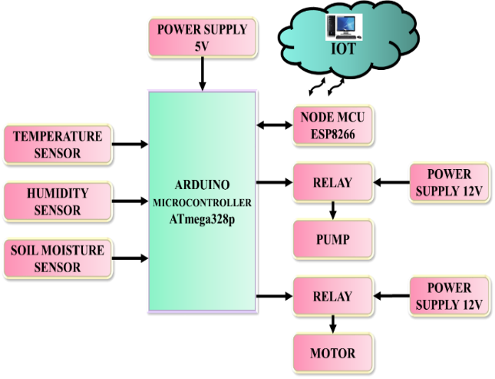

**Figure 1:** *Proposed block diagram*

## Mathematical Expressions and Symbols

Mathematical expressions and symbols should be inserted using **equation tool** of Microsoft word. References may be added for used equations to support its authenticity, e.g. this result has been analysed using Fourier series [5].

$f\left(x\right)=a_{0}+\sum_{n=1}^{∞}{\left(a_{n}\cos{\frac{nπx}{L}}+b_{n}\sin{\frac{nπx}{L}}\right)}$ (1)

# 4. Results and Discussion

This section may each be divided by subheadings or may be combined. A combined Results and Discussion section is often appropriate. This should explore the significance of the results of the work, don’t repeat them. Avoid extensive citations and discussion of published literature only, instead discuss recent literature for comparing your work to highlight novelty of the work in view of recent development and challenges in the field.

## 4.1 Preparation of Figures and Tables

Authors are supposed to embed all figures and tables at appropriate place within manuscript. Figures and tables should neither be submitted in separate files nor add at the end of manuscript. Figures and Tables should be numbered properly with descriptive title. Each Figure/Table must be explained within the text by referring to corresponding figure/table number. Any unexplained or unnumbered Figure/Table may cause rejection of the paper without being reviewed.

### 4.2 Formatting Tables

Table should be prepare using table tool within the Microsoft word and cited consecutively in the text. Every table must have a descriptive title and if numerical measurements are given, the units should be included in the column heading. Formatting requirement has been summarized in the Table 1.

**Table 1:** *Summary of formatting requirement for submitting paper in this journal.*

|  |  |  |  |  |  |
| --- | --- | --- | --- | --- | --- |
| Layout | **Size** | **Margin (Normal)** | **Header** | **Footer** |  |
| Single column | A4 (8.27” X 11.69”) | Top=2.54cm Bottom=2.54cm  Left=2.54cm Right=2.54cm | Do not add anything in the header | Do not add anything in the footer |  |
| Font | **Article Title** | **Headings** | **Subheadings** | **Reference list** | **Text** |
|  | Times New Roman, 16 pt, Bold, centred | Times New Roman, 12 pt, Bold, Left aligned | Times New Roman, 12 pt, Bold, Left aligned | Times New Roman, 10 pt, Justified | Times New Roman, 12 pt, Bold, Left aligned |
| Line Spacing | 1.15 | 1.15 | 1.15 | 1.15 | 1.15 |
| Page number | We will format and assign page numbers |  |  |  |  |

# 5 Conclusions

Each manuscript should contain a conclusion section within 250-450 words which may contain the major outcome of the work, highlighting its importance, limitation, relevance, application and recommendation. Conclusion should be written in continuous manner with running sentences which normally includes main outcome of the research work, its application, limitation and recommendation. Do not use any subheading, citation, references to other part of the manuscript, or point list within the conclusion.

**References**

All cited references should be listed after declarations section in the following style:

1. Amir Rezaei; Jeffrey B. Burl; Mohammad Rezaei; Bin Zhou, Year: 2018, “Catch Energy Saving Opportunity in Charge-Depletion Mode, a Real-Time Controller for Plug-In Hybrid Electric Vehicles”, IEEE Transactions on Vehicular Technology, Vol: 67, no: 11, pp. 11234 – 11237.

2. Jun Ni; Jibin Hu; Changle Xiang, Year: 2018, “Control-Configured-Vehicle Design and Implementation on an X-by-Wire Electric Vehicle”, IEEE Transactions on Vehicular Technology, Vol: 67, no: 5, pp. 3755 – 3766.

3. Duo Zhang; Guohai Liu; Huawei Zhou; Wenxiang Zhao, Year: 2018, “Adaptive Sliding Mode Fault-Tolerant Coordination Control for Four-Wheel Independently Driven Electric Vehicles”, IEEE Transactions on Industrial Electronics, Vol: 65, no: 11, pp. 9090 – 9100.

4. Bo Wang; Payman Dehghanian; Shiyuan Wang; Massimo Mitolo, Year: 2019, “Electrical Safety Considerations in Large-Scale Electric Vehicle Charging Stations”, IEEE Transactions on Industry Applications, Vol: 55, no: 6, pp. 6603 – 6612.